Name: __________________________________
The Enlightenment Web-Based Scavenger Hunt

Use the Enlightenment Philosopher PowerPoint to answer the following:
- Complete the chart below. Be as specific as possible
Name Philosophical Ideas/View of People View of Government (roles, rights, powers,etc.)
Rousseau
Thomas Hobbes
John Locke
Montesquieu
Voltaire
- Which of the Enlightenment philosophers wrote about and influenced the American system of Checks and Balances?

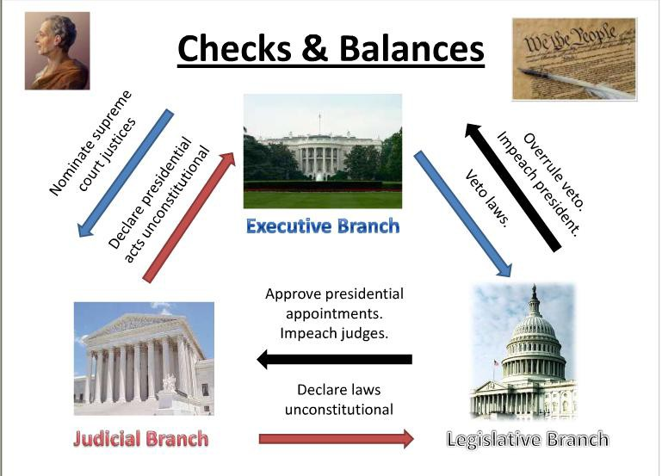

3) Which Enlightenment philosopher ‘s ideas were adapted and used in the Declaration of Independence:

_______________________________

4) What is the “supreme law of the land” in the United States?_________________________

